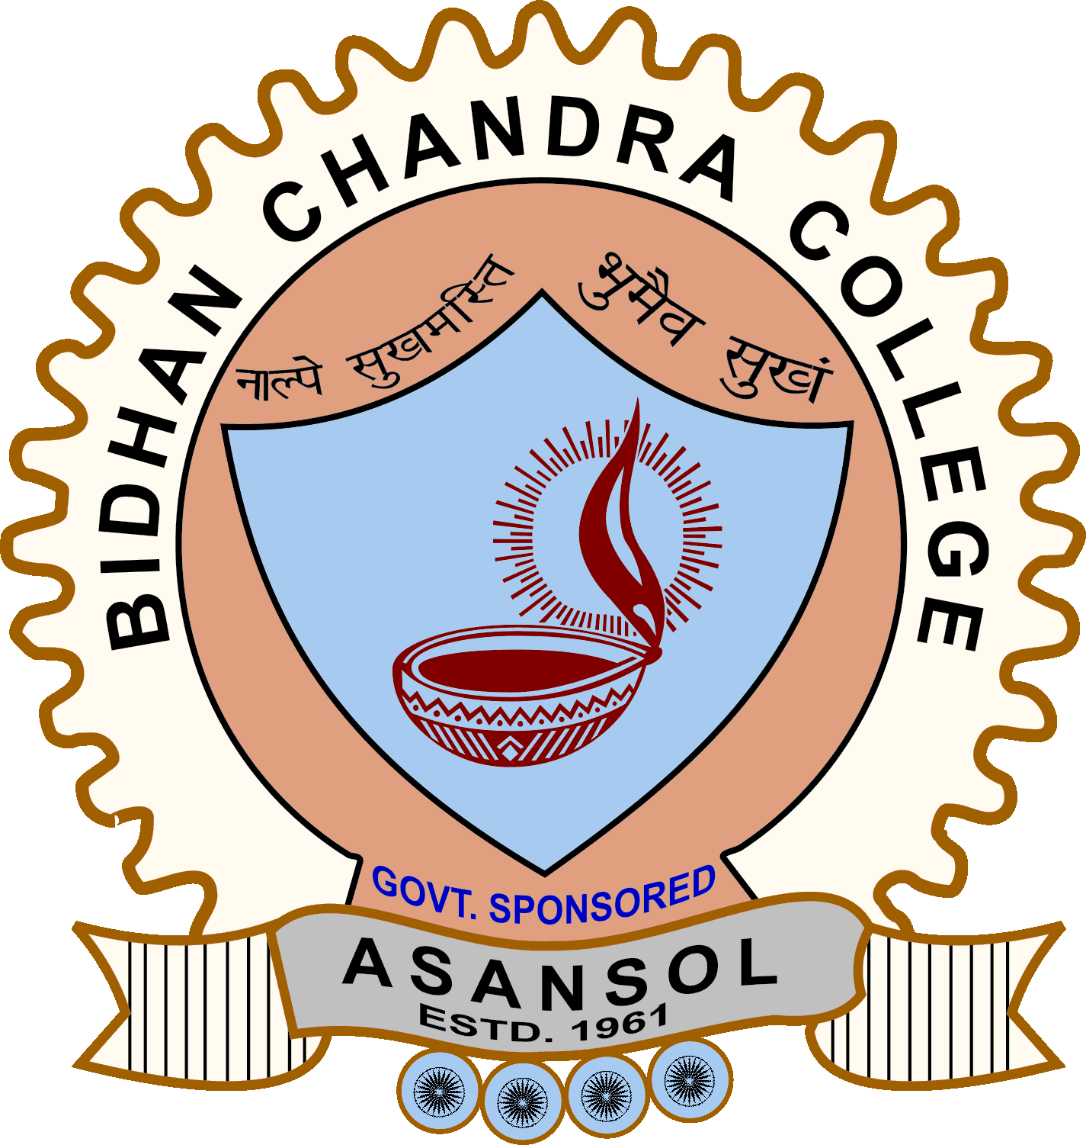Bidhan Chandra College
NAAC Accredited, [ Govt. Sponsored], ESTD: 1961
Recognized by U.G.C (Govt. of India) and affiliated to KaziNazrulUniversity
Asansol – 713304, Dist – Paschim Bardhaman , West Bengal , Ph : 0341-2283020
Visit us: www.bccollegeasansol.ac.in; E. Mail: office@bccollegeasansol.ac.in

Ref. No.: __________________________ Date: 03.09.2024

TO WHOM IT MAY CONCERN

The details of all suspended officials and staffs of the Institution:
Name of the Suspended Employee | Name of the Institution / Office with address | Suspended from | Reason for suspension | Any other details
NIL | Bidhan Chandra College, Shibdas Ghatak Sarani, Asansol – 713304, Paschim Bardhaman | NA | NA | NA

Dated: __________________________
[ Dr. Falguni Mukhopadhyay ]
Principal
BidhanChandraCollege
Asansol – 4.

